CSE 321: Operating Systems

Lab Assignment 4

Name: Mollah Md Saif

ID: 20101416

Section: 03

**Task 1**

#include<stdio.h>

#include<stdbool.h>

#define MAX_BURST_TIME 1000000

struct process {

int pid;

int arrival_time;

int const_burst_time;

int burst_time;

int waiting_time;

int turnaround_time;

};

int main() {

int n;

printf("Enter number of processes: ");

scanf("%d", &n);

printf("\n");

struct process processes[n];

for (int i = 0; i < n; i++) {

printf("Enter process %d \"process_id arrival_time burst_time\": ", i + 1);

scanf("%d %d %d", &processes[i].pid, &processes[i].arrival_time, &processes[i].burst_time);

processes[i].const_burst_time = processes[i].burst_time;

processes[i].waiting_time = 0;

processes[i].turnaround_time = 0;

}

bool is_running[n];

for (int i = 0; i < n; i++) {

is_running[i] = false;

}

bool is_completed[n];

for (int i = 0; i < n; i++) {

is_completed[i] = false;

}

int time = 0;

while(true)

{

//debug

/*

printf("Time: %d\n", time);

for (int i = 0; i < n; i++) {

printf("Process id: %d, burst time: %d, waiting time: %d, is running: %d, is completed: %d\n", processes[i].pid, processes[i].burst_time, processes[i].waiting_time, is_running[i], is_completed[i]);

}

printf("\n");

*/

// check arrived processes

for (int i = 0; i < n; i++) {

if (!is_completed[i] && !is_running[i] && processes[i].arrival_time <= time) {

is_running[i] = true;

}

}

// get shortest burst time of running processes

int shortest_burst_time = MAX_BURST_TIME;

int shortest_burst_time_index = -1;

for (int i = 0; i < n; i++) {

if (is_running[i] && processes[i].burst_time < shortest_burst_time) {

shortest_burst_time = processes[i].burst_time;

shortest_burst_time_index = i;

}

}

// run shortest burst time process

if (shortest_burst_time_index != -1) {

processes[shortest_burst_time_index].burst_time--;

if (processes[shortest_burst_time_index].burst_time == 0) {

is_running[shortest_burst_time_index] = false;

is_completed[shortest_burst_time_index] = true;

processes[shortest_burst_time_index].turnaround_time = processes[shortest_burst_time_index].waiting_time + processes[shortest_burst_time_index].const_burst_time;

}

}

// calculate waiting time

for (int i = 0; i < n; i++) {

if (i != shortest_burst_time_index && is_running[i]) {

processes[i].waiting_time++;

}

}

// finished all processes

for (int i = 0; i < n; i++) {

if (!is_completed[i]) {

goto not_finished;

}

}

break;

not_finished:

time++;

continue;

}

// print table

for (int i = 0; i < n; i++) {

printf("Process id: %d, Waiting time: %d, Turnaround time: %d\n", processes[i].pid, processes[i].waiting_time, processes[i].turnaround_time);

}

return 0;

}

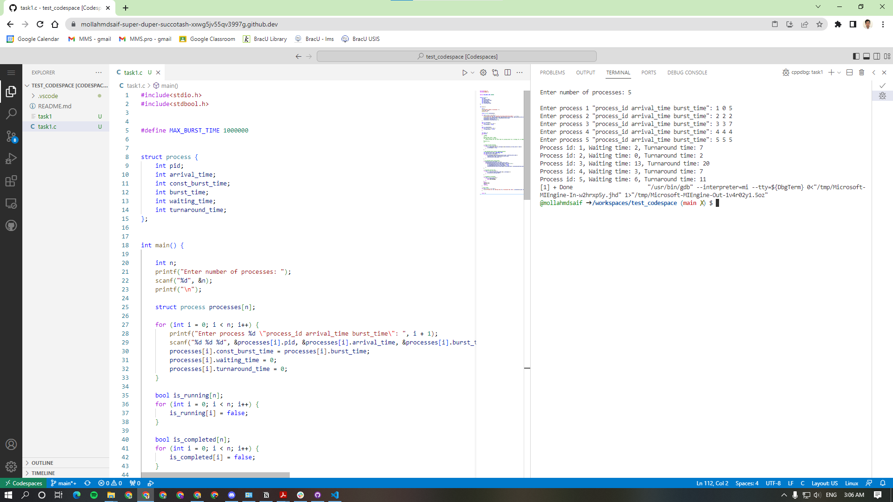

**Task 2**

#include<stdio.h>

#include<stdbool.h>

struct process {

int pid;

int const_burst_time;

int burst_time;

int waiting_time;

int turnaround_time;

};

int main() {

int time_quantum;

printf("Enter time quantum: ");

scanf("%d", &time_quantum);

printf("\n");

int n;

printf("Enter number of processes: ");

scanf("%d", &n);

printf("\n");

struct process processes[n];

for (int i = 0; i < n; i++) {

printf("Enter process %d \"process_id burst_time\": ", i + 1);

scanf("%d %d", &processes[i].pid, &processes[i].burst_time);

processes[i].const_burst_time = processes[i].burst_time;

processes[i].waiting_time = 0;

processes[i].turnaround_time = 0;

}

bool is_running[n];

for (int i = 0; i < n; i++) {

is_running[i] = true;

}

bool is_completed[n];

for (int i = 0; i < n; i++) {

is_completed[i] = false;

}

int time = 0;

int idx = 0;

while(true)

{

// run process

if (!is_completed[idx] && is_running[idx]) {

if (processes[idx].burst_time >= time_quantum)

{

processes[idx].burst_time -= time_quantum;

time += time_quantum;

} else {

time += processes[idx].burst_time;

processes[idx].burst_time -= processes[idx].burst_time;

}

}

// check if any process is completed

if (!is_completed[idx] && processes[idx].burst_time == 0) {

is_running[idx] = false;

is_completed[idx] = true;

processes[idx].turnaround_time = time;

}

// increment index

idx = (idx + 1) % n;

// finished all processes

for (int i = 0; i < n; i++) {

if (!is_completed[i]) {

goto not_finished;

}

}

break;

not_finished:

continue;

}

// calculate waiting time

for (int i = 0; i < n; i++) {

processes[i].waiting_time = processes[i].turnaround_time - processes[i].const_burst_time;

}

// print table

for (int i = 0; i < n; i++) {

printf("Process id: %d, Waiting time: %d, Turnaround time: %d\n", processes[i].pid, processes[i].waiting_time, processes[i].turnaround_time);

}

return 0;

}

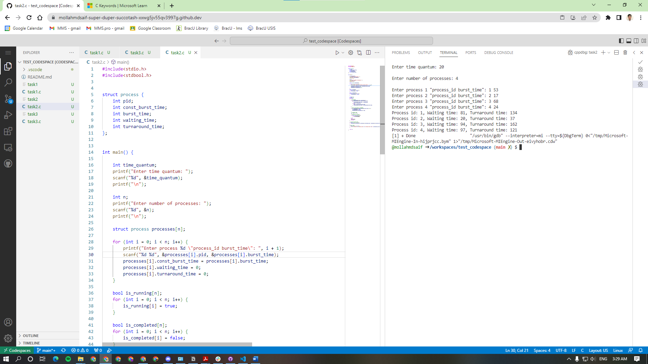

**Task 3**

#include<stdio.h>

#include<stdbool.h>

#define MAX_BURST_TIME 1000000

#define LOWEST_PRIORITY 1000000

struct process {

int pid;

int arrival_time;

int const_burst_time;

int burst_time;

int priority;

int waiting_time;

int turnaround_time;

};

int main() {

int n;

printf("Enter number of processes: ");

scanf("%d", &n);

printf("\n");

struct process processes[n];

for (int i = 0; i < n; i++) {

printf("Enter process %d \"process_id arrival_time burst_time priority\": ", i + 1);

scanf("%d %d %d %d", &processes[i].pid, &processes[i].arrival_time, &processes[i].burst_time, &processes[i].priority);

processes[i].const_burst_time = processes[i].burst_time;

processes[i].waiting_time = 0;

processes[i].turnaround_time = 0;

}

bool is_running[n];

for (int i = 0; i < n; i++) {

is_running[i] = false;

}

bool is_completed[n];

for (int i = 0; i < n; i++) {

is_completed[i] = false;

}

int time = 0;

while(true)

{

//debug

/*

printf("Time: %d\n", time);

for (int i = 0; i < n; i++) {

printf("Process id: %d, burst time: %d, waiting time: %d, is running: %d, is completed: %d\n", processes[i].pid, processes[i].burst_time, processes[i].waiting_time, is_running[i], is_completed[i]);

}

printf("\n");

*/

// check arrived processes

for (int i = 0; i < n; i++) {

if (!is_completed[i] && !is_running[i] && processes[i].arrival_time <= time) {

is_running[i] = true;

}

}

// get highest proirity of running processes

int highest_priority = LOWEST_PRIORITY;

int highest_priority_index = -1;

for (int i = 0; i < n; i++) {

if (is_running[i] && processes[i].priority < highest_priority) {

highest_priority = processes[i].priority;

highest_priority_index = i;

}

}

// run shortest burst time process

if (highest_priority_index != -1) {

processes[highest_priority_index].burst_time--;

if (processes[highest_priority_index].burst_time == 0) {

is_running[highest_priority_index] = false;

is_completed[highest_priority_index] = true;

processes[highest_priority_index].turnaround_time = processes[highest_priority_index].waiting_time + processes[highest_priority_index].const_burst_time;

}

}

// calculate waiting time

for (int i = 0; i < n; i++) {

if (i != highest_priority_index && is_running[i]) {

processes[i].waiting_time++;

}

}

// finished all processes

for (int i = 0; i < n; i++) {

if (!is_completed[i]) {

goto not_finished;

}

}

break;

not_finished:

time++;

continue;

}

// print table

for (int i = 0; i < n; i++) {

printf("Process id: %d, Waiting time: %d, Turnaround time: %d\n", processes[i].pid, processes[i].waiting_time, processes[i].turnaround_time);

}

return 0;

}

